**COMP9331 LAB1 – Tools of the trade**

Changfeng LI(z5137858)

**Exercise 1: nslookup**

Qs1-1: Which is the IP address of the Google site (www.google.com)? In your opinion, what is the reason of having several IP addresses as an output?

Qs1-2: Find out name of the IP address 127.0.0.1. What is special about this IP address?

As1-1: My host server is 129.94.0.196 with the address 129.94.0.196#53, The IP-Address of google site is 216.58.203.100.

A large website will have high traffic and usually it needs to handle numerous DNS requests. So multiple IP address can help reduce the burden of the server.

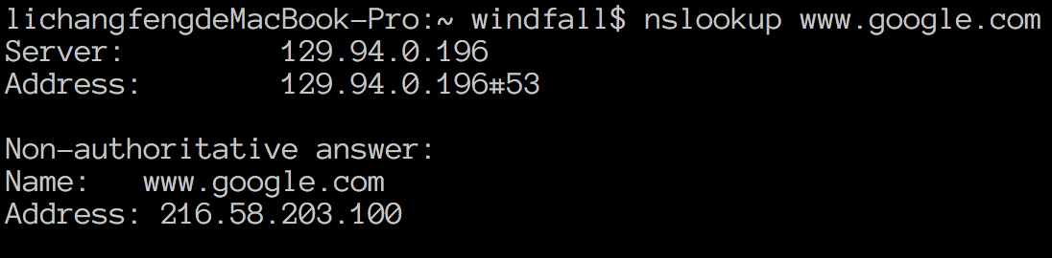

As1-2: The name of 127.0.0.1 is for localhost, and 127.0.0.1 is my local IP address. Actually Localhost is a domain name, not an address, it can be configured to any IP address, but usually it points to 127.0.0.1 (ipv4) and [::1] (ipv6).

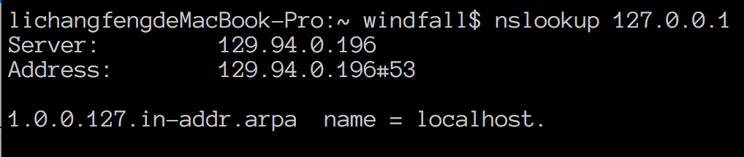

**Exercise 2: Use ping to test host reachability**

Qs2: Are the following hosts reachable from your machine by using ping:

* [www.cse.unsw.edu.au](http://www.cse.unsw.edu.au/)
* [www.getfittest.com.au](http://www.getfittest.com.au/)
* [www.mit.edu](http://www.mit.edu/)
* [www.intel.com.au](http://www.intel.com.au/)
* [www.tpg.com.au](http://www.tpg.com.au/)
* [www.hola.hp](http://www.hola.hp/)
* [www.amazon.com](http://www.amazon.com/)
* [www.tsinghua.edu.cn](http://www.tsinghua.edu.cn/)
* [www.kremlin.ru](http://www.kremlin.ru/)
* [8.8.8.8](https://webcms3.cse.unsw.edu.au/COMP3331/18s2/resources/8.8.8.8)

If you observe that some hosts are not reachable, then can you explain why? Check if the addresses unreachable by the ping command are reachable from the Web browser.

|  |  |  |
| --- | --- | --- |
| **Host** | **Result** | **Reason** |
| CSE(www.cse.unsw.edu.au) | 57/57 received packets  0.0% packet loss | Reachable |
| Getfittest(www.getfittest.com.au) | **100% packet loss** | Unreachable.  Not the legal site. |
| MIT(www.mit.edu) | 78/78 received packets  0.0% packet loss | Reachable |
| Intel(www.intel.com.au) | 95/95 received packets  0.0% packet loss | Reachable |
| TPG(www.tpg.com.au) | 53/54 received packets  1.9% packet loss | Reachable |
| Hola.hp | **Cannot resolve, unknown host** | Unreachable.  DNS could not be found. |
| Amazon | 102/102 received packets  0% packet loss | Reachable. |
| Tsinghua University | 117/117 received packets  0.0% packet loss | Reachable |
| Kremlin(www.kremlin.ru) | **100% packet loss** | The package is blocked by a firewall which aims at defending Service attacks. |
| 8.8.8.8 | 82/82 received packets  0.0% packet loss | Reachable |

**Exercise 3: Use traceroute to understand network topology**

Qs3-1: Run traceroute on your machine to [www.columbia.edu](http://www.columbia.edu/) . How many routers are there between your workstation and [www.columbia.edu](http://www.columbia.edu/) ? How many routers along the path are part of the UNSW network? Between which two routers do packets cross the Pacific Ocean? Hint: compare the round trip times from your machine to the routers using ping.

Qs3-2: Run traceroute from your machine to the following destinations: (i) [www.ucla.edu](http://www.ucla.edu/) (ii) [www.u-tokyo.ac.jp](http://www.u-tokyo.ac.jp/) and (iii) [www.lancaster.ac.uk](http://www.lancaster.ac.uk/) . At which router do the paths from your machine to these three destinations diverge? Find out further details about this router. (HINT: You can find out more about a router by running the whois command: whois router-IP-address). Is the number of hops on each path proportional the physical distance? HINT: You can find out geographical location of a server using the following tool - <http://www.yougetsignal.com/tools/network-location/>

Qs3-3: Several servers distributed around the world provide a web interface from which you can perform a traceroute to any other host in the Internet. Here are two examples: (i) <http://www.speedtest.com.sg/tr.php>and (ii) <https://www.telstra.net/cgi-bin/trace>. Run traceroute from both these servers towards your machine and in the reverse direction (i.e. from your machine to these servers). You may also try other traceroute servers from the list at [www.traceroute.org](http://www.traceroute.org/) . What are the IP addresses of the two servers that you have chosen. Does the reverse path go through the same routers as the forward path? If you observe common routers between the forward and the reverse path, do you also observe the same IP addresses? Why or why not?

As3-1:

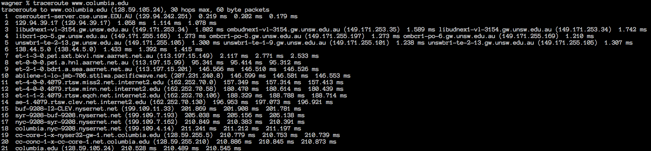

How many routers between my workstation and [www.columbia.edu](http://www.columbia.edu/) ?

* 21 routers(by ssh from home to CSE)

How many routers along the path are part of UNSW network?

* The first 5 routers

Between which two routers do packets cross the Pacific Ocean?

* Between #7 and #9
* #6 = still in Australia #10 = in Seattle, United States, and delay time from 2ms to 95ms to 147ms.

As3-2:

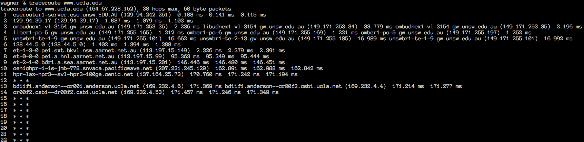

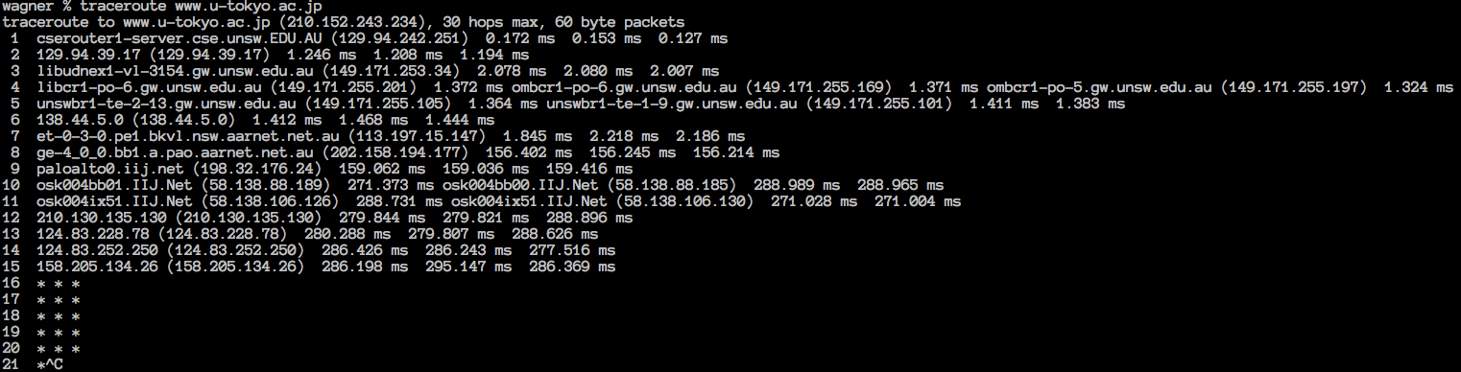

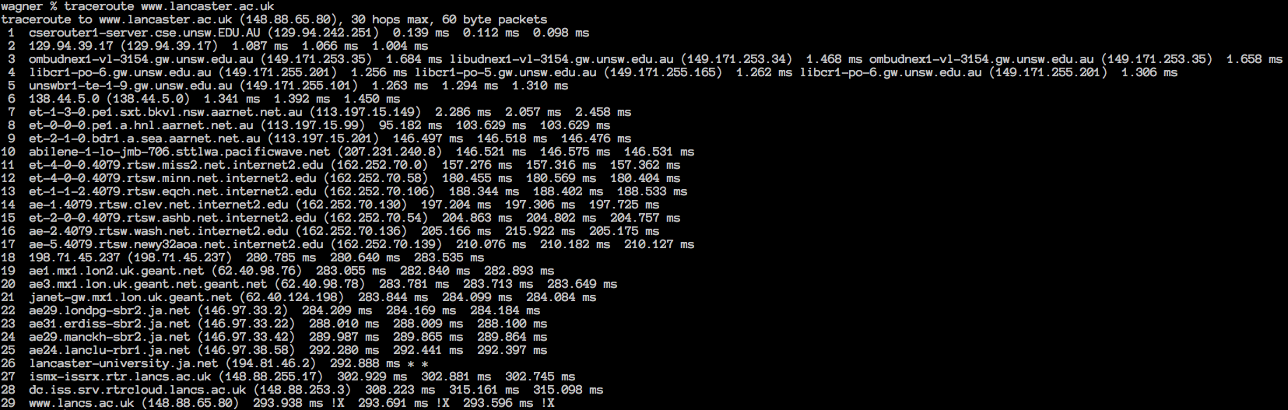

Which router do the paths from your machine to the three destinations diverge?

* The paths diverge at the router #6

Info about this router (whois):

* The IP address of this router is 138.44.5.0, This router belongs to the Australian Academic and Research Network. The details are showed below.

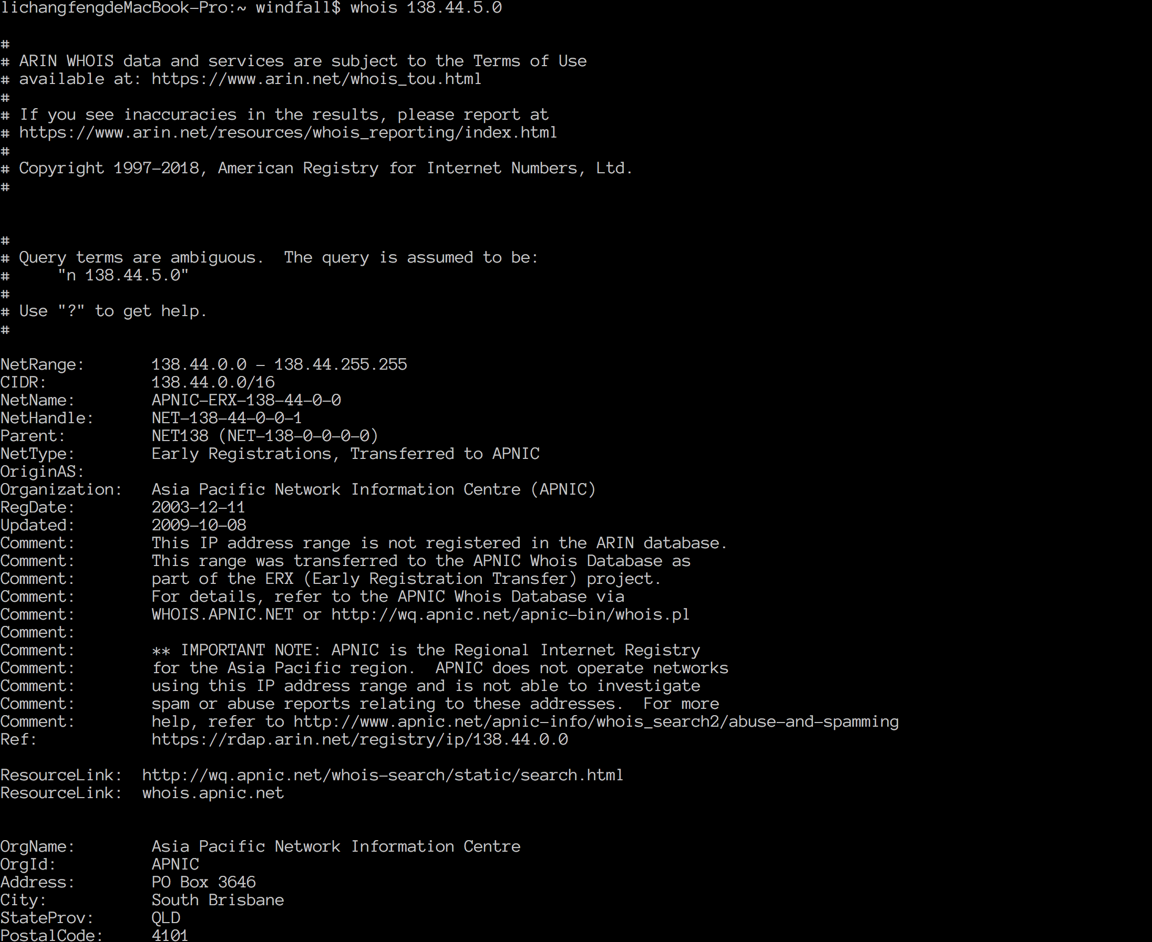

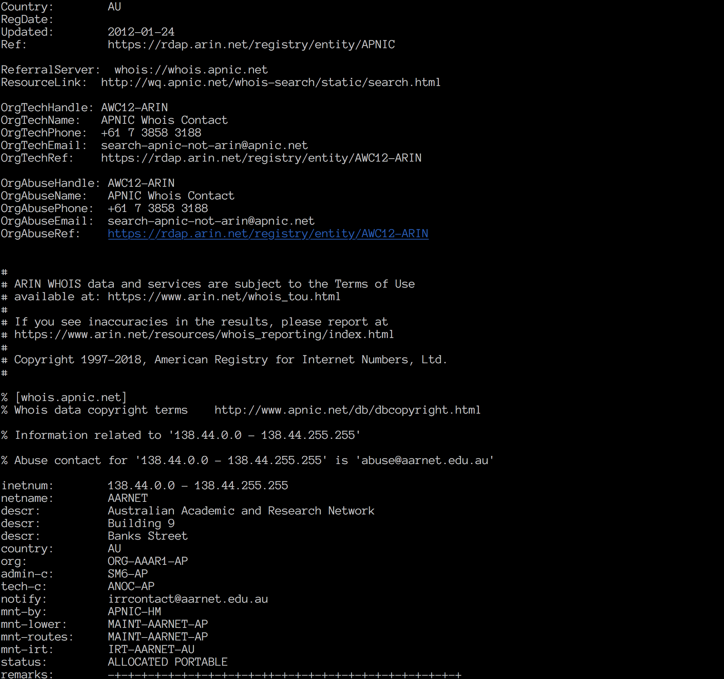

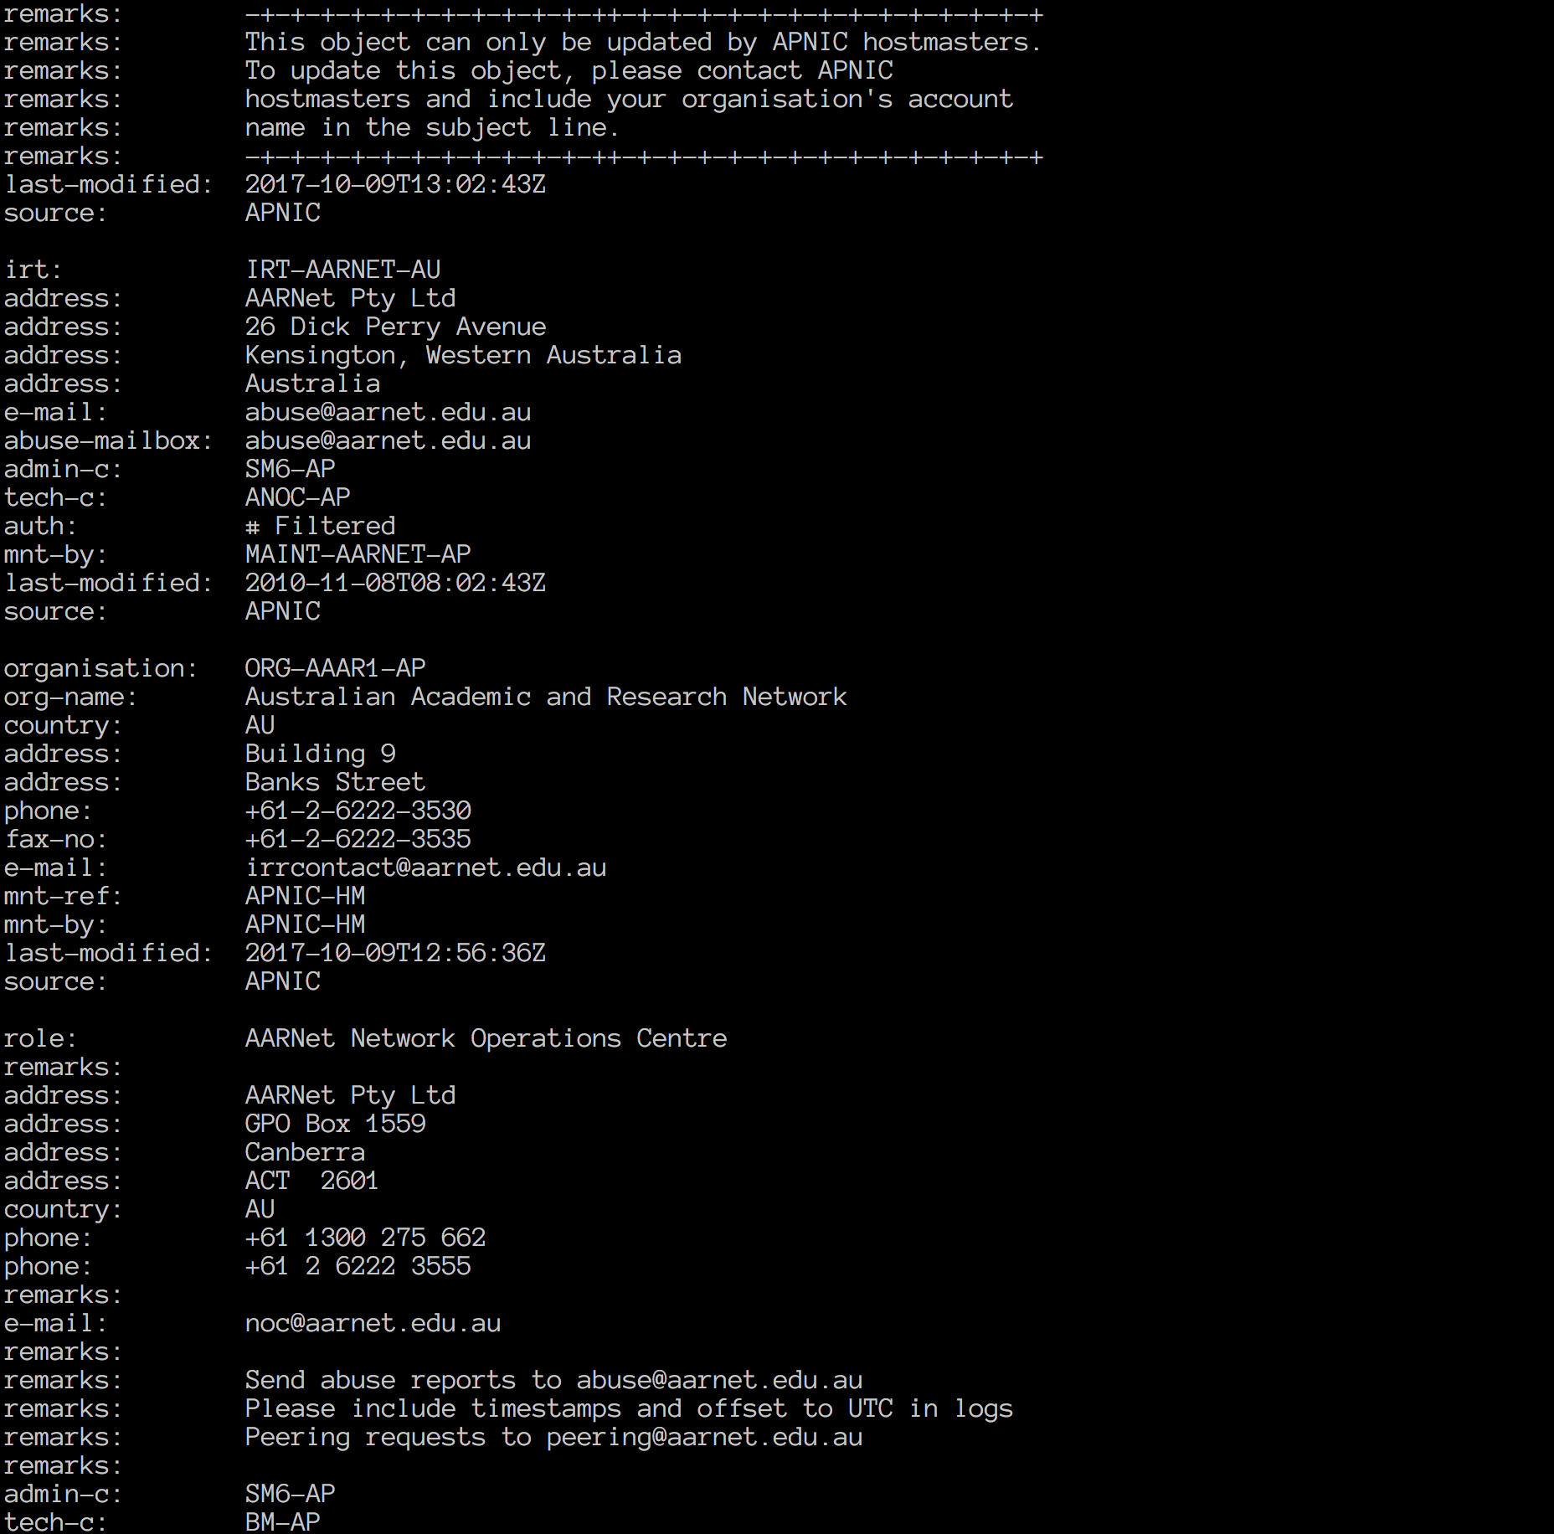

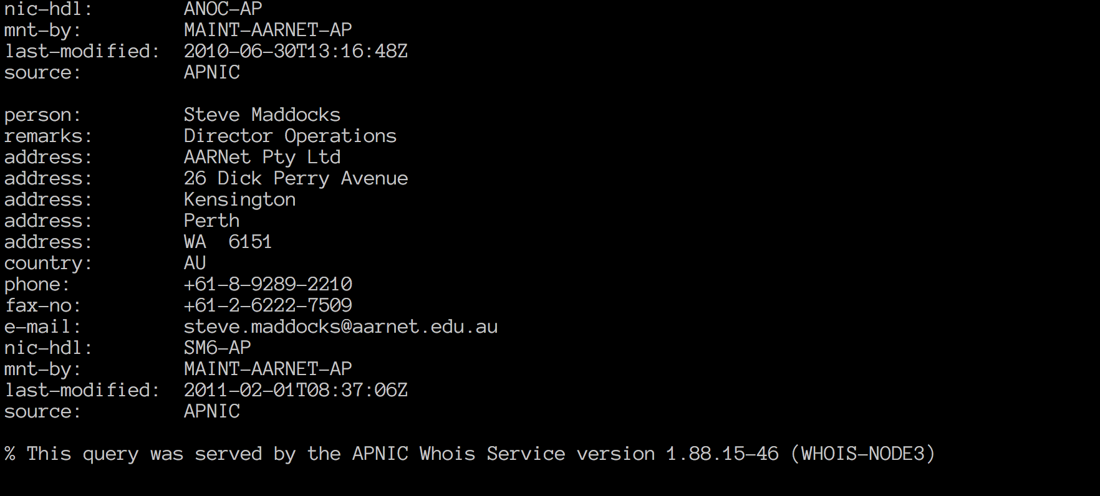

Is the number of hops on each proportional with the physical distance? (geographical distance)

• Geographical distance is calculated by using Google maps which helps measure straight line distance from my home to the dest

* Hops to UCLA: 14 hops =>12070 km
* Hops to UTOKYO: 15 hops => 7840 km

• Hops to LANCASTER: 29 hops => 17090 km

• It is not proportional, The distance between UTOKYO to UNSW with the shortest straight distance with just 15 hops, compared with UCLA with about twice the straight_line distance but taking only 14 hops before arriving at the destination. The reason might be the fact that there is limited numbers of network infrastructure around area near UTOKYO which limits the ability for network traffic to go through a more direct route to the location, so more routers are needed to reach UTOKYO.

As3-3

What are the IP addresses of the two servers that you have chosen

• I choose <http://www.speedtest.com.sg/tr.php> and <https://www.telstra.net/cgi-bin/trace>

1.Speedtest

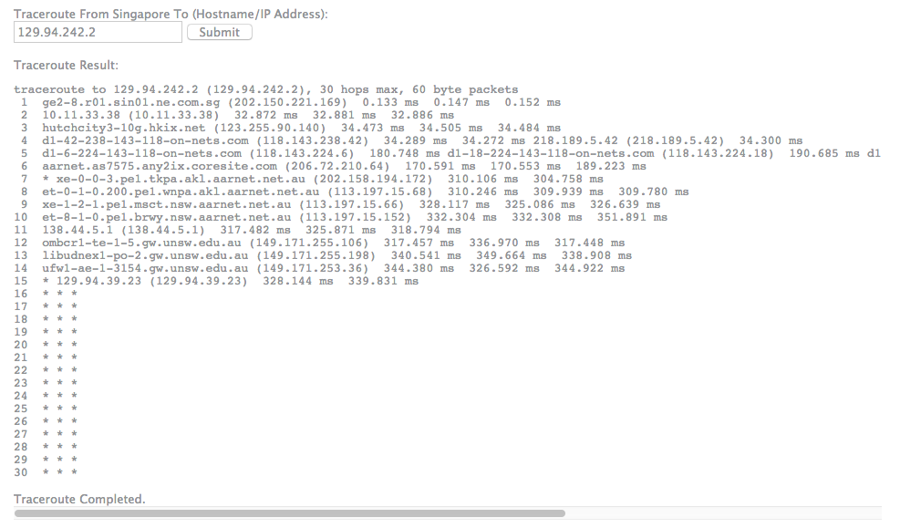

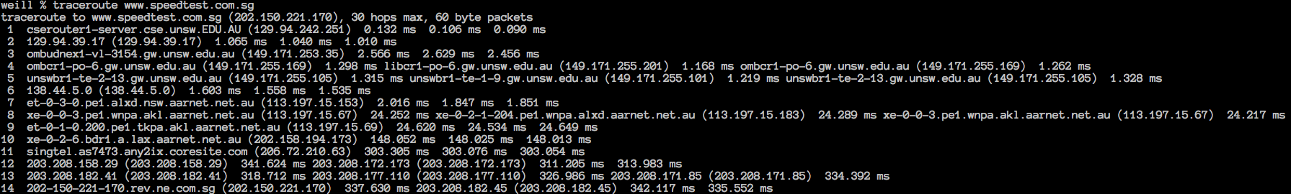

2.Telstra

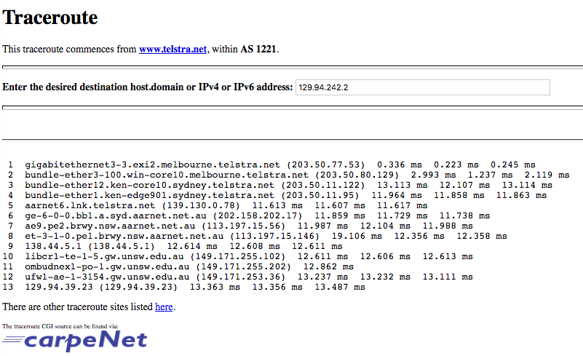

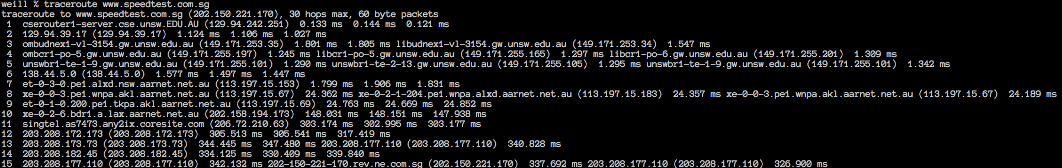

Does the reverse path go through the same routers as the forward path?

• The reverse path doesn’t go through the same routers as the forward path and also for some reason takes near twice as many hops to go from home from destination as from destination to home.

If you observe common routers between the forward and the reverse path, do you also observe the same IP addresses? Why or why not?

• This is likely because the routes are determined based on each router. Each one would have its unique set of routing rules so that path forward is not necessarily the same path to go through.

**Exercise 4: Use ping to gain insights into network performance**

Qs4-1: For each of these locations ﬁnd the (approximate) physical distance from UNSW using Google Maps and compute the shortest possible time T for a packet to reach that location from UNSW. You should assume that the packet moves (i.e. propagates) at the speed of light, 3 x 10^8 m/s. Note that the shortest possible time will simply be the distance divided by the propagation speed. Plot a graph where the x-axis represents the distance to each city (i.e. Adelaide, Singapore and Berlin), and the y-axis represents the ratio between the minimum delay (i.e. RTT) as measured by the ping program (select the values for 50 byte packets) and the shortest possible time T to reach that city from UNSW. (Note that the y-values are no smaller than 2 since it takes at least 2*T time for any packet to reach the destination from UNSW and get back). Can you think of at least two reasons why the y-axis values that you plot are greater than 2?

Qs4-2: Is the delay to the destinations constant or does it vary over time? Explain why.

Qs4-3: The measured delay (i.e., the delay you can see in the graphs) is composed of propagation delay, transmission delay, processing delay and queuing delay. Which of these delays depend on the packet size and which do not?

As4-1:From google map, we can note down the corresponding approximate physical distance from UNSW to these places. V_light = 3 * 10^8 m/s, Based on the file stores the delay info, we can calculate the ratio.

|  |  |  |  |
| --- | --- | --- | --- |
| **Destination** | **D(m)** | **T(s)** | **Y_axis:Ratio=RTT/T** |
| Brisbane | **720000** | **0.0024** | **17.690/2.4=7.37** |
| Singapore | **6400000** | **0.0213** | **143.79/21.3=6.75** |
| Berlin | **16000000** | **0.0533** | **298.865/53.3=5.61** |

Main reason of the fact that y-axis values that I plot are greater than 2:

1. Extra time for virus detecting.
2. Transmitting speed of Packets travel slower than the speed of light because of the issue of physical medium.

As4-2: 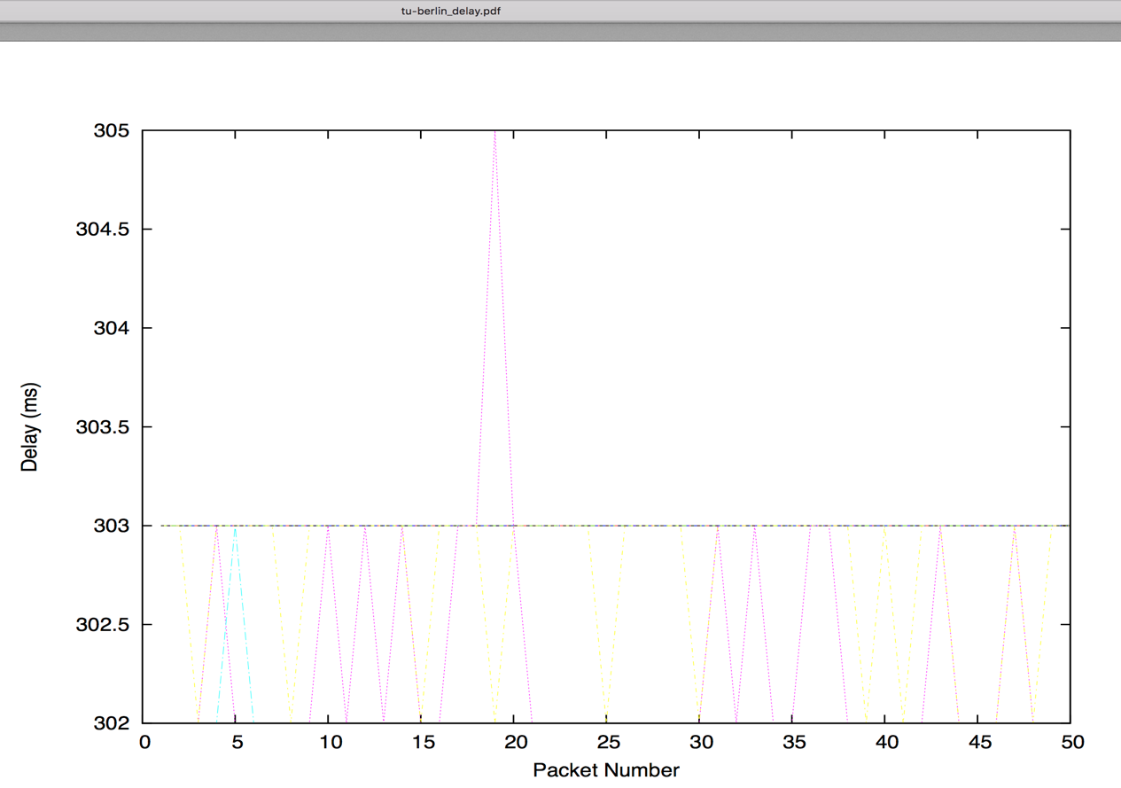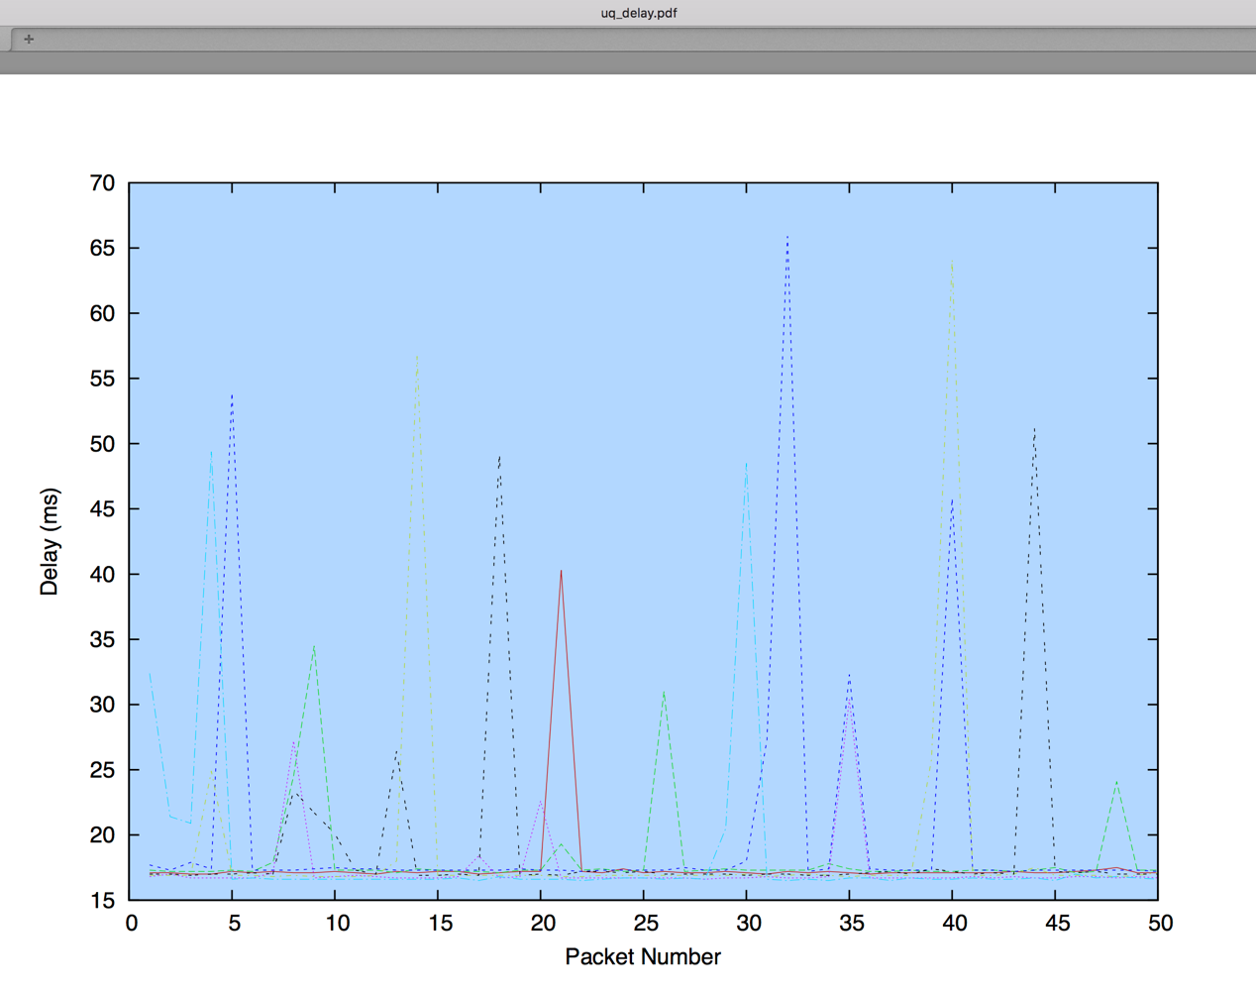

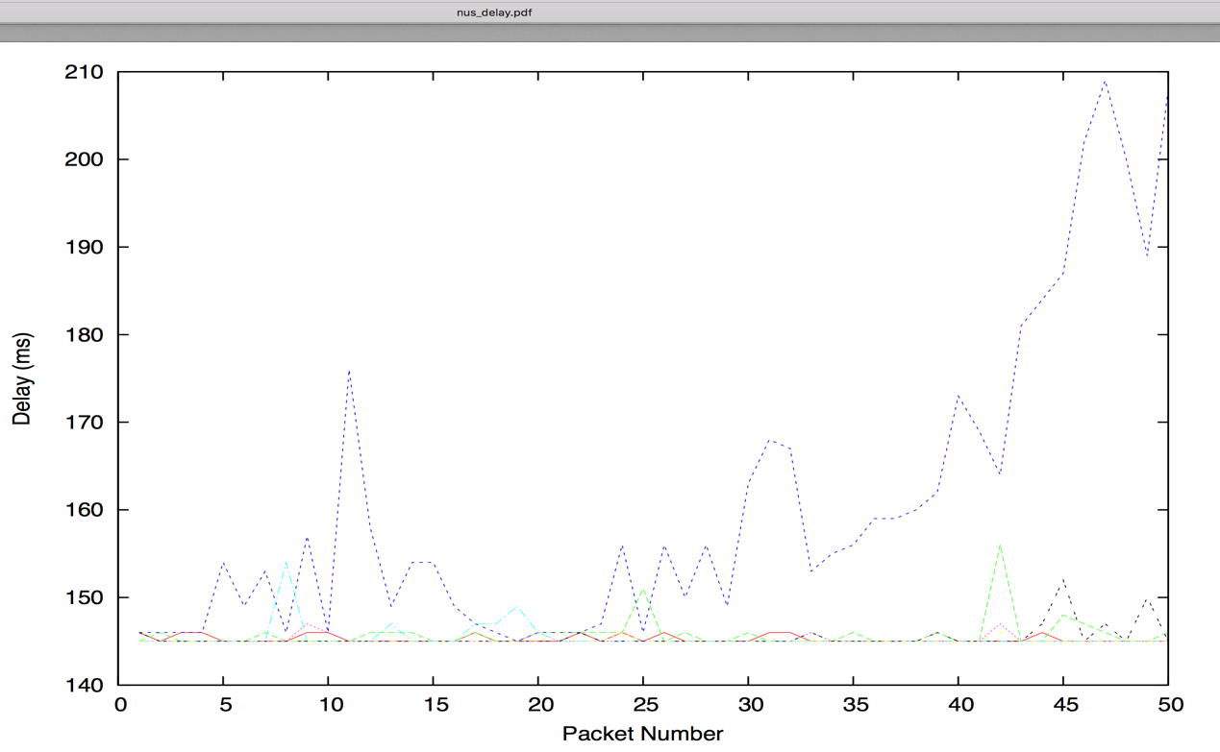

Obviously, the delay to the destinations vary over time. Because routers might be under busy status.

As4-3:

• Transmission delay = packet_length/rate of transmission. So when packet size changes, the delay changes as well.

• Propagation delay does not depend on the packet size. It’s due to the property of the medium of link.

• Processing delay are under low quantities, so when packetsize vary, the delay might change very little.

• Queuing delay = 1/service_speed – arrive_speed = 1/ transmission_speed/packet _size - arrive_speed. It is computed by the congestion of the network.

Thus, we can draw a conclusion that transmission delay depends on packet size.